**COMPONENTS OF THE PROJECT – SMART DATA LOGGING SYSTEM FOR INDUSTRIES**

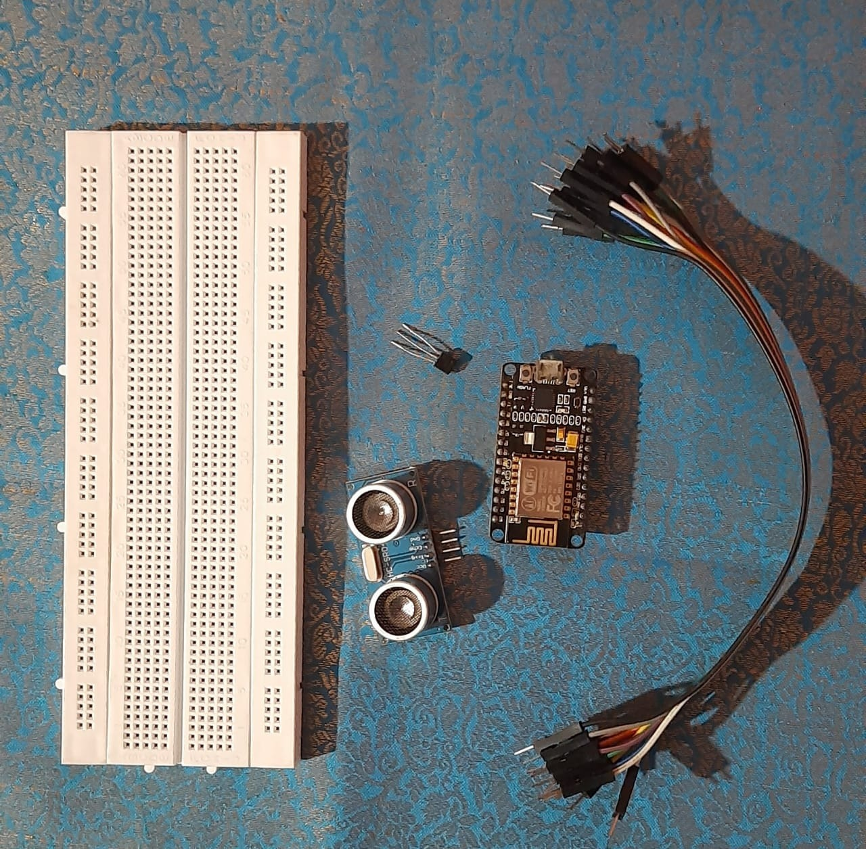

**HARDWARE SETUP**

